WEEK 03 — MACHINE LEARNING, NLP & LLM FOUNDATIONS

1. Machine Learning — Text Classification
[✓] Import the required libraries from scikit-learn.
[✓] Create a small text dataset with corresponding labels.
[✓] Convert text into numerical features using CountVectorizer or TF-IDF.
[ ] Split the dataset into training and testing sets.
[✓] Train a text classification model.
[✓] Generate predictions for new text.
[✓] Evaluate the model using accuracy and a classification report.
[✓] Explain the difference between training and inference.
Training vs. Inference:
- Training: The model learns patterns and updates its parameters using historical labeled data (model.fit(X_train, y_train)). It is computationally heavy and run offline.
- Inference: The model uses its frozen, already-learned parameters to make predictions on new, unseen data (model.predict(new_X)). It is fast and runs in real time.
Evidence of Phase 01:
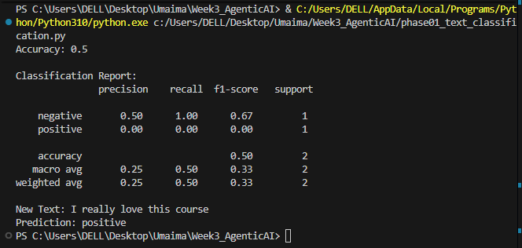

2. Natural Language Processing — Text Preprocessing
[✓] Implement a text-cleaning function in Python.
[✓] Remove unnecessary whitespace.
[✓] Convert text to lowercase where appropriate.
[✓] Remove punctuation where appropriate.
[✓] Test the preprocessing function using multiple sentences.
[✓] Explain why text preprocessing is useful.
Why text preprocessing is useful:
- Reduces Vocabulary Size: It converts word variations (like "Help", "help", and "HELP!") into a single standard token ("help").
- Removes Noise: It strips punctuation and extra whitespaces that carry no semantic value.
- Improves Model Accuracy: It creates smaller, cleaner feature representations, preventing the model from getting distracted by formatting differences.
Evidence of Phase 02:
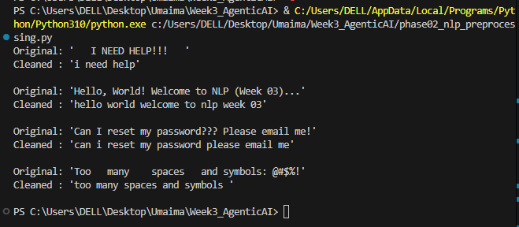

3. Tokenization
[✓] Install and import the required tokenizer libraries.
[✓] Load a pretrained tokenizer such as BERT's tokenizer.
[✓] Convert a sentence into tokens.
[✓] Convert tokens into token IDs.
[✓] Decode token IDs back into text.
[✓] Compare token counts for two different tokenizers.
[ ] Explain special tokens and subword tokenization.
- Special Tokens:
Reserved tokens added by the tokenizer to help transformer models understand text structure:
- [CLS]: Marks the start of a sequence and holds the overall sentence representation for classification.
- [SEP]: Marks sentence boundaries or separates paired sentences.
- [PAD]: Pads shorter sentences to match batch lengths for parallel processing.
- [UNK]: Replaces unknown words that are not in the vocabulary.
- Subword Tokenization:
A technique (like WordPiece or BPE) that breaks words into smaller meaningful units or morphemes:
- Common words stay whole (e.g., "model").
- Rare or compound words are split into known sub-pieces (e.g., "transforming" → ["transform", "##ing"]).
- Benefit: It eliminates Out-Of-Vocabulary (OOV) errors while keeping the dictionary size small and manageable (~30k tokens).

Evidence of Phase 03:
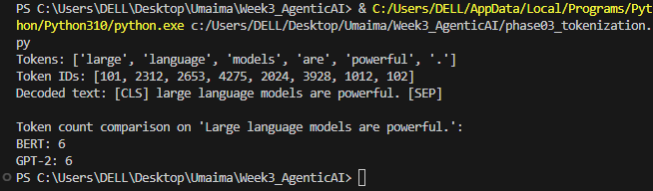

4. Advance Classification (added by me, as it was missed phase 4 in Week3 file)
[✓] Advance Classification
Evidence of Phase 04:
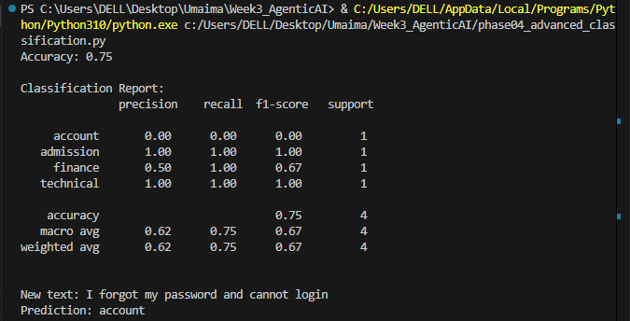

5. Embeddings and Semantic Similarity
[✓] Load a sentence-transformer model.
[✓] Generate embeddings for multiple sentences.
[✓] Calculate cosine similarity between two sentences.
[✓] Compare semantically similar and unrelated sentences.
[✓] Interpret the similarity scores.
[✓] Explain the difference between word counts and semantic embeddings.
Word Counts vs. Semantic Embeddings:
Word Counts (Bag of Words / TF-IDF):
- Counts exact matching words.
- If two sentences use different words to say the same thing (e.g., "doctor" vs. "physician"), the similarity score is 0.
- Ignores word order, grammar, and context.
Semantic Embeddings (Sentence Transformers):
- Represents sentences as dense mathematical vectors that capture meaning and intent.
- Understands synonyms and paraphrases (e.g., recognizes that "reset password" and "forgot credentials" mean the same thing).
- Understands full context and sentence structure.
Evidence of Phase 05:
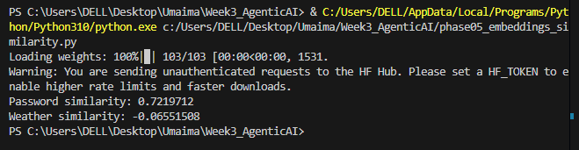

6. Semantic Search
[✓] Create a small collection of text documents.
[✓] Generate and store document embeddings.
[✓] Convert a user query into an embedding.
[✓] Calculate similarity between the query and documents.
[ ] Rank documents by similarity score.
[✓] Display the most relevant documents.
[✓] Test the search system using at least three different queries.
Evidence of Phase 06:
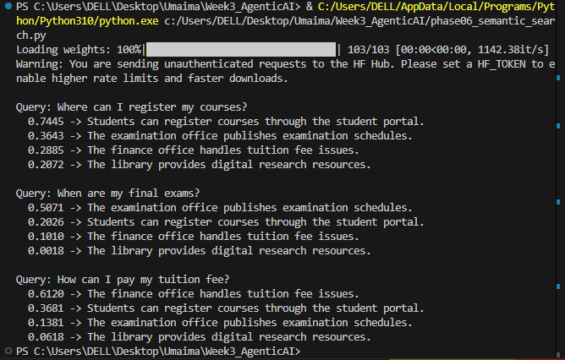

7. Code Quality and Submission
[✓] Organize the implementation into clearly named sections or functions.
[✓] Use meaningful variable and function names.
[✓] Run the code from beginning to end without unhandled errors.
[✓] Add comments where they clarify important logic.
[✓] Capture screenshots or output evidence.
[✓] Prepare a README with setup and execution instructions.
[✓] Submit the source code and required evidence.

